#### Student Activity 3

We have covered all the basics to get started with SQL, so create a new database and add some data. The E-R diagram for the database is as follows:

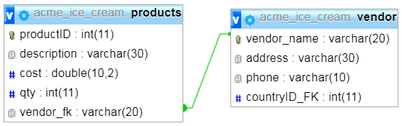

**Step One:** create a new database called “acme_ice_cream”, refer Figure 1

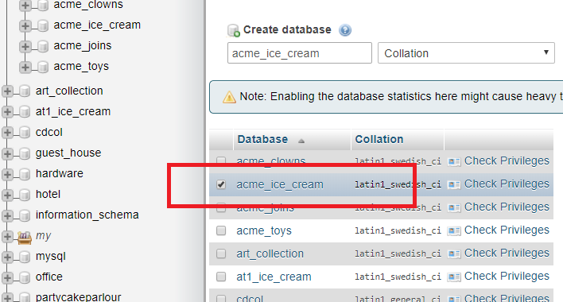

Figure 1

**Step Two:** add the following two tables. Table names: “products” and “vendor”, refer figure 2 and 3.

|  |  |  |  |  |
| --- | --- | --- | --- | --- |
| Table : vendor | | | | |
| Name | Type | Length/Value | Index | Comment |
| vendor_name | VARCHAR | 20 | Primary Key |  |
| address | VARCHAR | 30 |  |  |
| phone | VARCHAR | 10 |  |  |

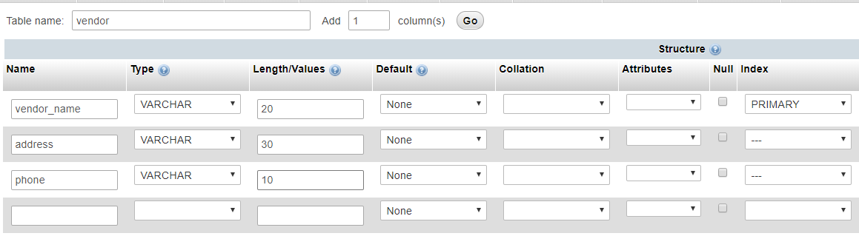

Figure 2

|  |  |  |  |  |
| --- | --- | --- | --- | --- |
| Table : products | | | | |
| Name | Type | Length/Value | Index | Comment |
| productID | INT | 11 | Primary Key | Auto Increment |
| description | VARCHAR | 30 |  |  |
| cost | DOUBLE | 10, 2 |  |  |
| qty | INT | 11 |  | Foreign |
| vendor_fk | VARCHAR | 20 | INDEX |  |

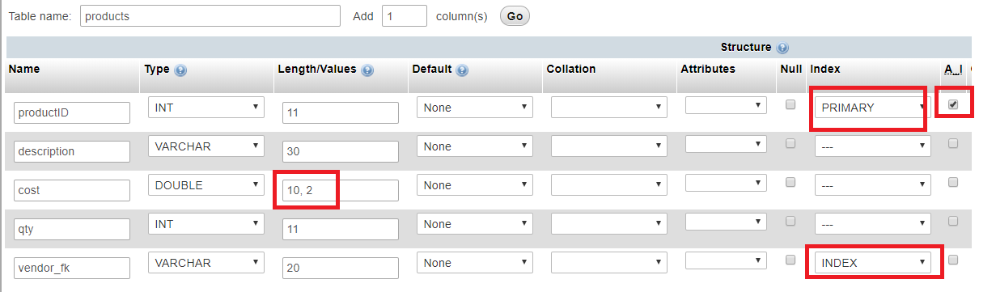

Figure 3

**Step Three:** add the relation between the two tables in the designer tab. Ensure you are at the top of the database hierarchy.

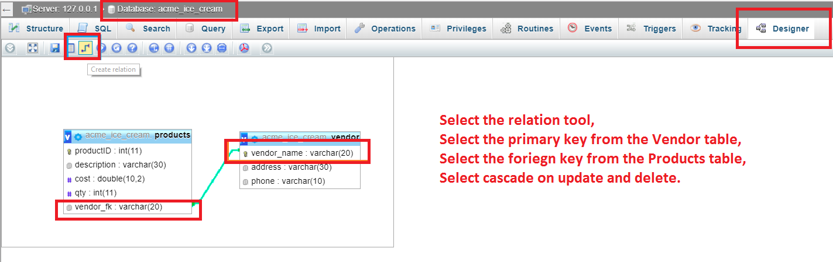

NOTE: The SQL file with table structure and data is located in the resource folder associated with this course.

**Step Four:** Add the data to the two tables using the SQL script “acme_ice_cream_data”. Browse the tables to check the details of the records, refer Figure 4.

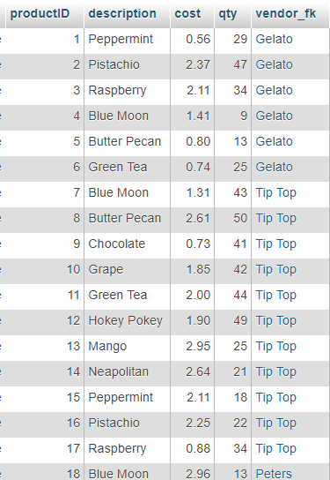 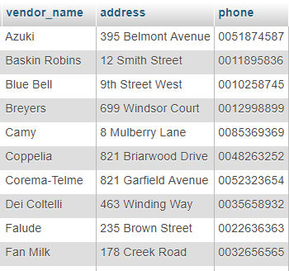

Figure 4

**Step Five:** open the SQL tab and examine the default statement; click “Go”. The results will show all the records from the table which is the same as the data from the Browse tab.

**Step Six:** Next we will select all the records where the quantity is less than 9. Open the SQL tab and copy/type the following SQL statement:

[SELECT](http://localhost/phpmyadmin/url.php?url=http%3A%2F%2Fdev.mysql.com%2Fdoc%2Frefman%2F5.5%2Fen%2Fselect.html) * FROM `products` WHERE `qty` < 9;

The results will be 9 records, refer Figure 5.

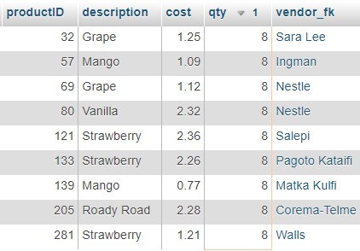

Figure 5

**Step Seven:** Write the SQL statement that will display all the records where the quantity is greater than or equal to 50.

[SELECT](http://localhost/phpmyadmin/url.php?url=http%3A%2F%2Fdev.mysql.com%2Fdoc%2Frefman%2F5.5%2Fen%2Fselect.html) * FROM `products` WHERE `qty` >= 50;

The results will be 10 records, How are the records ordered?

You should be able to answer the following questions;

Q1. List all the products made by TipTop.

Q2. List all the products that have a quantity greater than 10 and less than 40.

Q3. List all the products with a cost less than or equal to $1.50.

Q4. List all the products which are described as “Grape”

Q5. List all the Tutti Frutti products which cost more than $1.00.

Q6. List all the products that cost more than $2.90

Q7. List all the products that cost more than $2.90 and have a quantity greater than 24.

Q8. What is the average price of products described as “Green Tea”?

Q9. What is the cost of 4 Blue Moon ice creams made by Coppelia?

Q10. What is the total quantity of products described as Chocolate.

Optional

Q11. Increase the cost of all products by 10%.

End of Student Activity 3